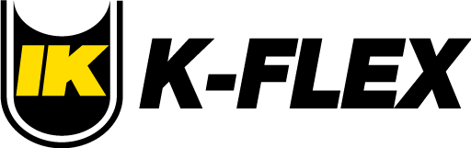

04/01/2026
Re: Price Increase Notification
Dear Valued Customer,
At K-Flex, we remain committed to delivering the industry’s highest-quality insulation products, exceptional service, and some of the most reliable lead times in the market. To continue upholding these standards, we must inform you of an upcoming price adjustment.
Due to unprecedented and immediate increases in raw material costs - driven by global supply chain disruptions - we are implementing a 10% price increase on all K-Flex products, effective 04/15/2026. This adjustment is necessary to maintain the premium product performance, consistency, and service excellence you rely on.
All orders entered for immediate shipment on or before 04/14/2026 will be honored at current pricing.
We understand that pricing changes can affect your planning, and we are fully committed to supporting you through this transition. We will honor required notification periods. Please feel free to contact me or your outside sales representative with any questions or to discuss your upcoming project needs.
We sincerely appreciate your trust in K-Flex as your preferred supplier of high-quality insulation solutions. Thank you for your continued partnership and support.
Best Regards.

Giuseppe Guarino
President - K-Flex USA

