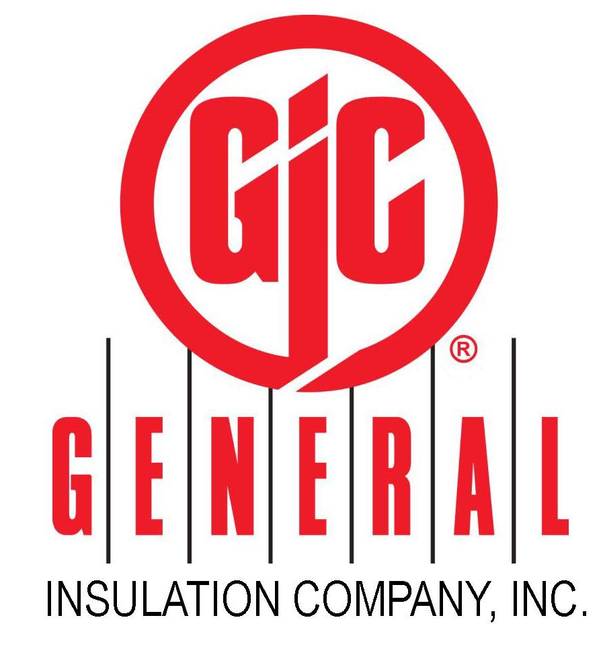
ESSENTIAL JOB FUNCTIONS:
- Works under the direction of the General and Operations Manager.
- Ensures all orders are pulled correctly and inventory is accurate.
- Unload/load all incoming and outgoing freight.
- Make all deliveries on time.
- Be the “eyes and ears” of the company in the field by reporting any customer feedback or competitive information to Operations or General Manager.
- Ensure cleanliness of warehouse and office area.
- Pick up materials from local vendors.
- Restock material.
- Clean Trucks.
- Work with Inside Sales to ensure routing of truck is efficient.
- Attend any branch meetings called on behalf of Operations or General Manager.
- Attend and work all mandatory Saturday physical inventories.
- Works the necessary hour work week in order to get the job done.
- Maintains safety mindset in all duties performed, especially (but not limited to) driving, material handling and job site evaluation.

MINIMUM QUALIFICATIONS:
Class B, CDL License required. Forklift certification and or experience is preferred. High school Diploma and preferably two (2) years of safe driving experience. Requires proficiency in the use of fork life and warehouse equipment. Must possess good communication skills with customers, teammates and employees at all levels of the company.

OTHER FUNCTIONS:
Performs additional functions (essential or otherwise), which may be assigned.

TYPICAL PHYSICAL DEMANDS:
Must be able to lift and move items of 70 pounds and/or more on a regular basis and repetitively lift weights of 40 - 50 pounds on raised surfaces. Must be able to climb, bend, kneel, crawl, and stoop on a frequent basis and for extended periods.

TYPICAL WORKING CONDITIONS:
Duties are performed typically in a warehouse/truck/driving environment.

SPECIAL REQUIREMENTS:
Must be at least 18 years of age and have a valid driver’s license. Must be willing to work odd hours including evenings, weekends, and holidays. Occasional travel required.

General Insulation Company offers competitive pay. Full time employees will become eligible for medical, dental, and vision benefits as well as our 401K program.

