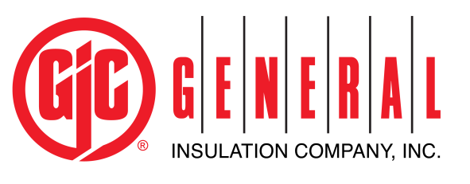
Outside Sales Representative
Company Description: General Insulation Company is a national wholesale distributor of commercial and industrial insulation products, HVAC supplies, 3M Firestop products, and associated construction supplies. It is the largest privately-held mechanical insulation distributor in North America. As a family owned company, we have built our business by providing the highest quality products and superior service to our customers. Founded in 1927, we have expanded to 50+ branch locations across the United States and Canada.
General Insulation fosters an environment that promotes learning, growth and success for all our employees. We work as a team to nurture and teach our employees in order to help them grow, evolve and reach their full potential. We seek candidates who are dedicated, talented and driven; they always push forward, seek innovation and are on a quest for self-improvement. Investing in our employees has enabled us to develop great leaders and in turn be our industry’s distributor of choice for over eighty-five years.
Position Summary: Execute branch/corporate sales strategies to meet short and long-term goals/objectives. Provide timely information based on market research and analysis of the competitive landscape. Provide technical support and inside sales help to branch operations while ensuring that our customer service is consistently highest caliber. Respond promptly to customer needs, solicit customer feedback to improve service, respond to requests for service/assistance and deliver on all commitments.
Essential Job Functions:
- Maintain relationships and provide excellent customer service for existing customers.
- Maintain superior product knowledge in all areas of GIC services and products.
- Establish and build new business relationships with prospective customers in order to grow the business.
- Provide product pricing, literature, safety data documentation and all related materials to existing and prospective customers.
- Create and conduct effective presentations/technical workshops to train the marketplace, customers and GIC team as needed.
- Maintain accurate records of all sales and prospecting activities including sales calls, presentations, and closed sales.
- Develop annual business plan and target accounts in conjunction with Sales Manager.
- Maintain competitive database.
- Maintain a positive working relationship with vendors, requesting joint sales calls as indicated.
- Prepare a weekly schedule of customer sales calls.
- Communicate pertinent sales and market information to Branch Manager, Operations Manager and Inside Sales Representative
Minimum Qualifications:
- Associates Degree or higher preferred
- 2-5 years’ experience in a quota carrying sales role.
- Must possess excellent communication skills with customers, teammates and employees at all levels of the company.

Special Requirements:

- Detail oriented. Small details may have a large impact on a product’s overall cost. Well organized and attention to detail.
- Technical skills. Detailed knowledge of industry processes, materials, and costs are vital. In addition, use of specialized computer programs to calculate equations and handle large databases. Product and software knowledge, or the ability to learn quickly.
- Time-management skills. Fixed deadlines require planning in advance and work efficiently and accurately. Ability to meet deadlines / quick turnaround.
- Writing skills. Must be able to write detailed reports. Often, these reports determine whether or not contracts are awarded or products are manufactured.
Benefits:
General Insulation offers a wide array of benefits including Medical, Dental, Vision, 401K with a discretionary match, Life Insurance, Long Term Disability, Short Term Disability, Health Savings Accounts, Tuition Reimbursement and more. All employees who enroll in a medical plan are also enrolled in an employer sponsored Life Insurance Policy.

