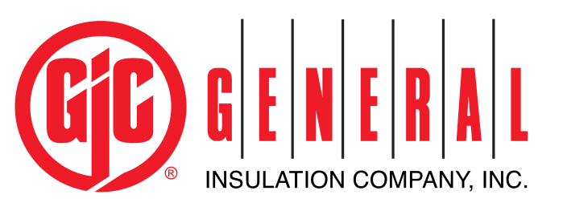
Inside Sales Representative
Company Description: General Insulation Company is a national wholesale distributor of commercial and industrial insulation products, HVAC supplies, 3M Firestop products, and associated construction supplies. It is the largest privately-held mechanical insulation distributor in North America. As a family owned company, we have built our business by providing the highest quality products and superior service to our customers. Founded in 1927, we have expanded to 50+ branch locations across the United States and Canada.
General Insulation fosters an environment that promotes learning, growth and success for all our employees. We work as a team to nurture and teach our employees in order to help them grow, evolve and reach their full potential. We seek candidates who are dedicated, talented and driven; they always push forward, seek innovation and are on a quest for self-improvement. Investing in our employees has enabled us to develop great leaders and in turn be our industry’s distributor of choice for over eighty-five years.
Essential Job Functions:
- Works under the direction of the General Manager as well as in conjunction with the Outside Sales Representative and Regional Sales Manager.
- Handle incoming customer calls by answering questions and following up with product recommendations and price quotes utilizing great customer service techniques.
- Strive to build customer relationships that will support continued relationships and sales growth.
- Responsible for updating the company CRM (SMP) on a daily basis ensuring all information is up to date and accurate for sales forecasting.
- Building a pipeline of potential customers utilizing product knowledge and past projects completed.
- Provide support to outside sales team by maintaining Product Literature/Samples, communicating customer activity and providing leads.
- Qualifies sales opportunities through market / customer research and teaming with outside sales representatives.
- Utilizing social media to increase customer base, contacting potential customers and selling products available.
- Identify and analyze different customer profiles to promote more sales and new opportunities
- Develops sales solutions for customers as well as reevaluating needs of the customer based on past sales
- Receive and process orders in E-Term.
- Provides consistent communication with warehouse personnel to ensure customer needs are met.
- Must be comfortable with change, possess an entrepreneurial spirit and have ability to think outside the box.
- Ensures bid follow ups and helps customers resolve issues with orders.
- Understand the company’s vision, and business objectives to set and accomplish individual performance goals.
Minimum Qualifications:
- High school Diploma
- 1-2 years of inside sales experience
- 2 years customer service experience
- Must possess excellent communication skills with customers, teammates and employees at all levels of the company.
Special Requirements:
- Detail oriented – organized and full knowledge of the company policies, products and services
- Product Knowledge – may have assigned product responsibility, including but not limited to; promotion assigned product, developing product literature for customers, educating other employees about product
- Problem Solver - helping customers to understand the products they will need or eventually need based on upcoming projects. Foreshadow anything they may need in the future based on present sales.
- Technical skills – Basic telephone skills, proficient in Microsoft Office Suite and relevant sales systems
- Time-management skills. Fixed deadlines require planning in advance and work efficiently and accurately. Ability to meet deadlines / quick turnaround.
- Must be willing to work odd hours including evenings, holidays, and weekends. Occasional travel may be required.
Benefits:
General Insulation offers a wide array of benefits including Medical, Dental, Vision, 401K with a discretionary match, Life Insurance, Long Term Disability, Short Term Disability, Health Savings Accounts, Tuition Reimbursement and more. All employees who enroll in a medical plan are also enrolled in an employer sponsored Life Insurance Policy.

