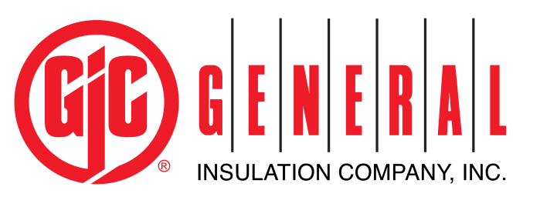
Customer Development Representative
Company Description: General Insulation Company is a national wholesale distributor of commercial and industrial insulation products, HVAC supplies, 3M Firestop products, and associated construction supplies. It is the largest privately-held mechanical insulation distributor in North America. As a family owned company, we have built our business by providing the highest quality products and superior service to our customers. Founded in 1927, we have expanded to 50+ branch locations across the United States and Canada.
General Insulation fosters an environment that promotes learning, growth and success for all our employees. We work as a team to nurture and teach our employees in order to help them grow, evolve and reach their full potential. We seek candidates who are dedicated, talented and driven; they always push forward, seek innovation and are on a quest for self-improvement. Investing in our employees has enabled us to develop great leaders and in turn be our industry’s distributor of choice for over eighty-five years.
Essential Job Functions:
- Works under the direction of the General Manager in conjunction with the Outside Sales Representative and Regional Sales Manager
- Ensure bid follow up and helps resolve customer issues
- Qualify business opportunities through market research for lead generation
- Prioritize and coordinate customer/prospect opportunities with Outside Sales Representative
- Identify and analyze customer profiles to promote additional sales and new opportunities
- Generate a pipeline of business by developing sales solutions for customers as well as evaluating the needs of the customer
- Responsible for updating the company CRM (SMP) on a daily basis ensuring all information is up to date and accurate for sales forecasting
- Provide support to outside sales team by maintaining superior product knowledge and understanding
- Utilizing social media platforms to identify, increase, and communicate with, identify, increase customer base
- Provide consistent communication with General and Operations Manager to ensure customer needs are met
- Strive to build customer relationships that will support continued sales growth
- Must be comfortable with change, possess an entrepreneurial spirit and have ability to think outside the box
- Understand the company’s vision, and business objectives to set and accomplish individual and branch performance goals
Minimum Qualifications:
- High school Diploma
- 1-2 years of inside sales experience
- 2 years customer service experience
- Must possess excellent communication skills with customers, teammates and employees at all levels of the company.
Special Requirements:
- Detail oriented – organized and full knowledge of the company policies, products and services
- Product Knowledge – may have assigned product responsibility, including but not limited to; promotion assigned product, developing product literature for customers, educating other employees about product
- Problem Solver - helping customers to understand the products they will need or eventually need based on upcoming projects. Foreshadow anything they may need in the future based on present sales.
- Technical skills – Basic telephone skills, proficient in Microsoft Office Suite and relevant sales systems
- Time-management skills. Fixed deadlines require planning in advance and work efficiently and accurately. Ability to meet deadlines / quick turnaround.
- Must be willing to work odd hours including evenings, holidays, and weekends. Occasional travel may be required.
Benefits:
General Insulation offers a wide array of benefits including Medical, Dental, Vision, 401K with a discretionary match, Life Insurance, Long Term Disability, Short Term Disability, Health Savings Accounts, Tuition Reimbursement and more. All employees who enroll in a medical plan are also enrolled in an employer sponsored Life Insurance Policy.

Employee Signature: ___________________________________________________ Date: ________________________

